write first program in python

Sure! Let's start with a very simple and classic first program in Python: the "Hello, World!" program. This program will print the text "Hello, World!" to the screen.

Steps to Write Your First Python Program

1. Install Python
Make sure Python is installed on your computer. You can download it from python.org. Follow the installation instructions for your operating system.

2. Open Your Text Editor or IDE
You can use any text editor or IDE (Integrated Development Environment) such as VSCode, PyCharm, Sublime Text, or even the default IDLE that comes with Python.

3. Write the Code
Type the following line of code:
python
Copy code
print("Hello, World!")

4. Save the File
Save the file with a .py extension, for example, hello.py.

5. Run the Program
Open a terminal or command prompt, navigate to the directory where you saved the file, and run the following command:
sh
Copy code
python hello.py
You should see the output:
Copy code
Hello, World!

Detailed Explanation
- print Function: The print() function is used to output text to the console. In this case, it outputs the string "Hello, World!".
- Quotation Marks: The text inside the print() function is enclosed in quotation marks ("). This tells Python that it is a string.

Full Example
Here’s the complete example again for clarity:
python
Copy code
print("Hello, World!")

Running the Program
- On Windows:
  - Open the Command Prompt.
  - Navigate to the directory where your hello.py file is saved using the cd command.
  - Run the script by typing python hello.py.
- On macOS/Linux:
  - Open the Terminal.
  - Navigate to the directory where your hello.py file is saved using the cd command.
  - Run the script by typing python3 hello.py (or python hello.py if you have set up Python 3 as the default).
Congratulations! You've written and executed your first Python program. From here, you can start exploring more complex programs and learning more about the Python language.
4o
Formal and natural languages in python
ChatGPT
In the context of Python and programming in general, the terms "formal language" and "natural language" refer to different ways of expressing information. Here’s an explanation of both:

Formal Language
A formal language is a language with a precise syntax and semantics, used for specific purposes such as programming, mathematics, and logic. In the case of Python, the formal language is the Python programming language itself. It has strict rules and syntax that must be followed in order for the code to run correctly.

Characteristics of Formal Language:
- Syntax and Grammar: Rules that define how statements must be written (e.g., indentation in Python).
- Precision: Every statement has a clear and unambiguous meaning.
- Executable: Instructions can be executed by a computer to perform specific tasks.

Example in Python:
Here’s a simple example of Python code (a formal language):
python
Copy code
def greet(name):
return f"Hello, {name}!"

print(greet("Alice"))
In this example:
- def is a keyword used to define a function.
- greet(name): is a function definition with a parameter name.
- return f"Hello, {name}!" returns a formatted string.
- print(greet("Alice")) calls the function and prints the result.

Natural Language
Natural language refers to the language used by humans for everyday communication, such as English, Spanish, Chinese, etc. Natural languages are inherently ambiguous and context-dependent, making them difficult for computers to understand and process directly.

Characteristics of Natural Language:
- Ambiguity: Words and sentences can have multiple meanings.
- Context-Dependent: Meaning can change based on context.
- Expressiveness: Rich in idioms, expressions, and variations.

Example of Natural Language:
Here’s an example of a natural language description of the same task:
"Write a function named greet that takes a person's name as an argument and returns a greeting message. Then call this function with the name 'Alice' and print the result."

Differences and Relationship
- Precision vs. Ambiguity: Formal languages are precise and unambiguous, while natural languages are often ambiguous and context-dependent.
- Purpose: Formal languages are designed for computers to execute specific tasks, whereas natural languages are designed for human communication.
- Structure: Formal languages have strict syntax rules, while natural languages have more flexible grammar and structure.

Using Both in Python Programming
When programming in Python, you often use natural language for documentation, comments, and communication with other developers, and formal language (Python code) for writing the actual instructions that the computer will execute.

Example Combining Both:
python
Copy code
# This function returns a greeting message
def greet(name):
"""
Greet the person with the given name.

Parameters:
name (str): The name of the person to greet.

Returns:
str: A greeting message.
"""
return f"Hello, {name}!"

# Call the function and print the result
print(greet("Alice"))
In this example:
- The comment # This function returns a greeting message is a natural language comment explaining what the function does.
- The docstring """ ... """ inside the function provides a natural language description of the function’s parameters and return value.
- The actual code is written in the formal language (Python).
Understanding the distinction between formal and natural languages helps in writing clear and effective code, as well as in documenting and explaining your code to others.

why use python
ChatGPT
Python is a popular programming language for a variety of reasons, making it a preferred choice for beginners and experienced developers alike. Here are some key reasons to use Python:

1. Ease of Learning and Use
- Simple Syntax: Python's syntax is clear and readable, which makes it easier to learn and write code. It often looks like pseudocode, making it intuitive for beginners.
- Minimalist Approach: Python requires fewer lines of code to perform the same task compared to many other languages. This simplicity helps developers focus on solving problems rather than worrying about complex syntax.

2. Versatility
- Multi-Paradigm: Python supports multiple programming paradigms, including procedural, object-oriented, and functional programming, giving developers flexibility in how they write their code.
- Wide Range of Applications: Python can be used for web development, data analysis, artificial intelligence, machine learning, scientific computing, automation, and more.

3. Extensive Libraries and Frameworks
- Standard Library: Python comes with a rich standard library that supports many common programming tasks, from file I/O to network programming and beyond.
- Third-Party Libraries: Python has a vast ecosystem of third-party libraries and frameworks, such as NumPy, pandas, Matplotlib for data science; Django, Flask for web development; TensorFlow, PyTorch for machine learning; and many more.

4. Community Support
- Active Community: Python has a large, active community of developers who contribute to its development, create libraries, write tutorials, and provide support on forums.
- Extensive Documentation: Python's official documentation is comprehensive, and there are numerous tutorials, courses, and books available to help developers of all skill levels.

5. Cross-Platform Compatibility
- Platform Independent: Python runs on various platforms, including Windows, macOS, and Linux, making it a versatile choice for development across different operating systems.
- Interoperability: Python can easily integrate with other languages and technologies, such as C, C++, Java, and .NET, allowing for a broader range of applications.

6. Productivity and Speed
- Rapid Development: Python’s simplicity and readability allow for faster development cycles, which can be especially beneficial for startups and prototyping.
- Maintenance: Python code is easier to read and maintain, which can lead to reduced costs and improved productivity over the long term.

7. Strong Support for Data Science and AI
- Data Science: Python is the go-to language for data science and analytics, thanks to powerful libraries like pandas, NumPy, and SciPy.
- Machine Learning and AI: Libraries such as TensorFlow, Keras, and PyTorch make Python a leading language for machine learning and AI research and development.

8. Automation and Scripting
- Scripting Capabilities: Python is excellent for writing scripts to automate repetitive tasks, whether they are simple file operations or complex system administration tasks.
- Integration: Python’s ability to easily interact with other technologies makes it a good choice for automation and orchestration in various environments.

Example Code in Python
Here’s a simple example that demonstrates Python’s readability and ease of use. This program calculates the factorial of a number:
python
Copy code
def factorial(n):
"""Return the factorial of a given number n."""
if n < 0:
return "Factorial is not defined for negative numbers"
elif n == 0:
return 1
else:
result = 1
for i in range(1, n + 1):
result *= i
return result

number = int(input("Enter a number: "))
print(f"The factorial of {number} is {factorial(number)}")

Conclusion
Python is widely used and loved because of its simplicity, versatility, extensive libraries, and strong community support. Whether you are a beginner looking to learn programming or an experienced developer working on complex projects, Python offers a robust and flexible toolset to meet your needs.

Here’s a concise summary with bullet points and brief explanations for each key reason to use Python:

Why Use Python?
- Ease of Learning and Use
  - Simple Syntax: Clear and readable, resembling pseudocode.
  - Minimalist Approach: Requires fewer lines of code for tasks compared to other languages.
- Versatility
  - Multi-Paradigm Support: Procedural, object-oriented, and functional programming.
  - Wide Range of Applications: Web development, data analysis, AI, machine learning, scientific computing, automation, etc.
- Extensive Libraries and Frameworks
  - Rich Standard Library: Supports common tasks like file I/O, networking, and more.
  - Third-Party Libraries: Ecosystem includes NumPy, pandas, Django, Flask, TensorFlow, PyTorch, and more.
- Community Support
  - Active Community: Large and supportive developer community.
  - Comprehensive Documentation: Extensive official docs, tutorials, and educational resources.
- Cross-Platform Compatibility
  - Platform Independent: Runs on Windows, macOS, Linux.
  - Interoperability: Integrates with languages like C, C++, Java, and .NET.
- Productivity and Speed
  - Rapid Development: Faster development cycles due to simplicity and readability.
  - Easy Maintenance: Code is easier to read and maintain.
- Strong Support for Data Science and AI
  - Data Science Libraries: Powerful tools like pandas, NumPy, SciPy.
  - Machine Learning Frameworks: Leading tools like TensorFlow, Keras, PyTorch.
- Automation and Scripting
  - Scripting Capabilities: Ideal for automating repetitive tasks.
  - Integration: Easily interacts with other technologies and tools.

Example Code:
python
Copy code
def factorial(n):
"""Return the factorial of a given number n."""
if n < 0:
return "Factorial is not defined for negative numbers"
elif n == 0:
return 1
else:
result = 1
for i in range(1, n + 1):
result *= i
return result

number = int(input("Enter a number: "))
print(f"The factorial of {number} is {factorial(number)}")
Python’s simplicity, versatility, and strong community support make it an excellent choice for both beginners and experienced developers across various domains.

Uses of Python
- Web Development
  - Frameworks: Django, Flask, Pyramid
  - Explanation: Python is widely used for backend development, offering robust frameworks like Django for full-stack applications and Flask for microservices.
- Data Science and Analysis
  - Libraries: Pandas, NumPy, Matplotlib
  - Explanation: Python’s data science libraries facilitate tasks such as data manipulation, analysis, and visualization, making it a top choice for data-centric projects.
- Machine Learning and Artificial Intelligence
  - Libraries: TensorFlow, PyTorch, scikit-learn
  - Explanation: Python's machine learning and AI libraries empower developers to create intelligent systems and predictive models, driving advancements in various fields.
- Scientific Computing
  - Libraries: SciPy, SymPy
  - Explanation: Python is utilized in scientific computing for tasks like simulations, mathematical computations, and symbolic mathematics, thanks to libraries like SciPy and SymPy.
- Automation and Scripting
  - Tools: Selenium, Requests
  - Explanation: Python's simplicity and versatility make it ideal for automating tasks and scripting, with tools like Selenium for web automation and Requests for HTTP requests.
- Desktop GUI Applications
  - Libraries: Tkinter, PyQt
  - Explanation: Python can be used to develop cross-platform desktop applications with graphical user interfaces (GUIs), leveraging libraries like Tkinter and PyQt.
- Game Development
  - Libraries: Pygame, Panda3D
  - Explanation: Python offers frameworks like Pygame for 2D game development and Panda3D for 3D game development, making it suitable for game development projects.
- Network Programming
  - Libraries: socket, Twisted
  - Explanation: Python's network programming capabilities enable developers to build networked applications, servers, and clients using libraries like socket and Twisted.
Python's versatility and extensive ecosystem of libraries and tools make it a preferred choice for a wide range of applications, spanning from web development and data science to AI, scientific computing, and beyond.

Strengths of Python
- Ease of Learning and Use:
  - Python's simple and readable syntax makes it easy for beginners to learn and write code.
  - It requires fewer lines of code compared to other languages, enhancing productivity.
- Versatility:
  - Python supports multiple programming paradigms, including procedural, object-oriented, and functional programming.
  - It can be used for various applications, such as web development, data science, machine learning, automation, and more.
- Extensive Libraries and Frameworks:
  - Python has a rich ecosystem of libraries and frameworks for different domains, reducing the need to build functionalities from scratch.
  - Libraries like NumPy, pandas, TensorFlow, and Django provide powerful tools for specific tasks, making development faster and more efficient.
- Community Support:
  - Python has a large and active community of developers who contribute to its development, create libraries, write tutorials, and provide support on forums and communities.
  - Comprehensive documentation and resources are available, making it easier to find solutions to problems.
- Cross-Platform Compatibility:
  - Python code can run on various platforms, including Windows, macOS, and Linux, without any modifications.
  - It offers seamless interoperability with other languages and technologies, allowing integration with existing systems.

Drawbacks of Python
- Performance:
  - Python is an interpreted language, which can lead to slower performance compared to compiled languages like C++ or Java.
  - Performance-critical applications may require optimization or integration with faster languages for certain parts of the code.
- Global Interpreter Lock (GIL):
  - In multithreaded Python programs, the Global Interpreter Lock (GIL) can limit performance by allowing only one thread to execute Python bytecode at a time.
  - This can impact the performance of multithreaded applications, especially on multi-core systems.
- Packaging and Deployment:
  - Packaging and distributing Python applications can be challenging, especially when dealing with dependencies and version compatibility.
  - Different packaging tools and environments (e.g., virtual environments, containers) are often used to manage dependencies and ensure reproducibility.
- Mobile Development:
  - While Python can be used for mobile app development (e.g., with frameworks like Kivy or BeeWare), it is not as commonly used as languages like Java or Swift for native mobile development.
  - Cross-platform mobile development with Python may have limitations compared to native development.
- Not Suitable for Low-Level System Programming:
  - Python is not well-suited for low-level system programming tasks like operating system development or device driver programming, where performance and control over hardware are critical.
Despite these drawbacks, Python remains a popular and widely-used programming language due to its simplicity, versatility, and extensive ecosystem of libraries and frameworks. It excels in various domains and continues to evolve with the needs of developers and the industry.

Disadvantages of Python
Last Updated : 02 Nov, 2023

Python is a widely used general-purpose, high-level programming language. It is widely used by developers in various domains, from web development to Machine Learning. However, Python has its own set of advantages and disadvantages

Cons of Python Programming
- Python is Slow at Runtime
- Mobile Application Development
- Difficulty in Using Other Languages
- High Memory Consumption
- Not used in the Enterprise Development Sector
- Runtime Errors
- Simplicity

Python is Slow at Runtime
Python is an interpreted language and is slow compared to C/C++ or Java. Unlike C or C++ it’s not closer to hardware because Python is a high-level language. As we all know compilation and execution help to work normally, but in this case, the execution of Python takes place with the help of an interpreter instead of the compiler as we have seen that Python code is executed line by line, which causes it to slow down.

Mobile Application Development
Python is not a very good language which means it is a weak language for mobile development. It is very rarely used for mobile development. This is the reason very few mobile applications are built into it like Carbonnelle, which is built in Python.

Difficulty in Using Other Languages
The Python lovers become so accustomed to its features and its extensive libraries that they face problem in learning or working on other programming languages.

High Memory Consumption
For any memory intensive tasks Python is not a good choice. That is why it is not used for that purpose. Python’s memory consumption is also high, due to the flexibility of the data types.

Not used in Enterprise Development Sector
this language is highly insecure and can be used only at one’s own risk. There are some limitations of Python with database access. In comparison to the popular technologies like JDBC and ODBC, it is found that Python’s database access layer is a bit underdeveloped and primitive.

Runtime Errors
One of the major drawbacks of this language is that its design has numerous issues. Python programmers face several issues regarding the design of the language. This language requires more testing and also it has errors that only show up at runtime this is because the language is dynamically typed.

Simplicity
Python is a simple programming language which is also the biggest disadvantage. It can indeed be a problem. Its syntax is very simple which makes a programmer more of python person and because of which they might feel code of harder language like Java unnecessary. It concludes that with its late-binding dynamic models and extensive libraries, shifting to a new language from Python gets difficult as the user finds it difficult to adjust to its vulnerable nature and taking everything on a light note.

What is a python interpreter?

The Python interpreter is the core component of the Python programming language. Interpreters are the computer program that will convert the source code or an high level language into intermediate code (machine level language). It is also called translator in programming terminology. Interpreters executes each line of statements slowly. This process is called Interpretation. For example Python is an interpreted language, PHP, Ruby, and JavaScript.

What is the difference between a python interpreter and a compiler?
Computer programs are generally written in a high-level language, also called source code. Since machines don’t understand this type of language, the language needs to be transformed into binary or machine code, which machines understand.
Compilers and interpreters make this transformation possible. However, while they both have the primary function of changing source code into machine code, there are differences between them.
Interpreters translate source code one statement at a time. On the other hand, the compiler first scans the entire program and then translates the whole program into machine code.
Let’s consider these.
- Interpreters translate programs one statement at a time, unlike compilers that do “batch translation.” Therefore, interpreters usually take less time to analyze the source code. However, while they analyze code faster, compilers execute the code faster than interpreters.
- Secondly, because interpreters don’t generate any Object code, they are more memory efficient than compilers.

Are compilers better than interpreters, then?
It depends on what you want. Programs with interpreters can run right away and be started faster. Furthermore, interpreters make debugging your code easier since they identify line-by-line errors.
Any changes made to the code written via a compiler will require it to be converted. Compilers no longer use computing power, making them more efficient.

How does an interpreter work in python?
The Python interpreter is CPython and is written in the C programming language. So how does CPython work? Let’s see.

Interpreters start with source code analysis.
First, the interpreter checks or analyzes the source code. By now, we assume you know what the source code means. It’s the high-level language you write programs in.
So, CPython receives the source code and initializes several commands to do some vital things.
First, the interpreter ensures you follow Python’s syntax for writing code.
It also checks for incorrect lines of code. If it encounters any error in a line, it stops the program from running and produces an error message.
This analysis divides the source code files into a list of tokens.

The interpreter then generates byte code.
After lexical analysis, which is the process described in the section above, the interpreter moves to the second stage, byte code generation.
After receiving the tokens, the interpreter generates the Abstract Syntax Tree or AST. This tree is converted to machine language (i.e., 1s and 0s). Because this is a Python interpreter, the code can be saved in a file with the .pyc extension.

Next, the interpreter initializes a PVM.
The interpreter initializes the Python Virtual Machine (PVM) in the next step. PVM is crucial because it’s what converts the byte code into binary code.
After conversion, the results are then printed. Python prints out the correct result if there are no high-level language errors. Otherwise, it prints out an error message.s

What is Python Script?

Python is a well-known high-level programming language. The Python script is a file containing Python-written code. The file containing Python script has the extension ‘.py’ or can also have the extension ‘.pyw’ if it is being run on a Windows 10 machine.
To run a Python script, we need a Python interpreter installed on the device. In this article, we will learn how to run a Python script.

Methods to Run a Script in Python
There are various methods to Run a Python script, we will go through some generally used methods for running a Python script:
- Interactive Mode
- Command Line
- Text Editor (VS Code)
- IDE (PyCharm)

How to Run a Python Script?
Let’s go through the basic steps and understand how a script works.
Here is a simple code to print ‘Hello World!’.
print('Hello World!')

To Execute this program, first we have to save it with the ‘.py’ extension. Then we can execute this file with the help of the terminal.
Here, the print() function is to print out any text written within the parenthesis. We can write the text that we want to be printed using either a single quote as shown in the above script or a double quote.

with Python, you do not need to specify a semicolon at the end of the line. And also we don’t need to include or import any files to run a simple Python script.
before going toward the different ways to run a Python script, we first have to check whether a Python interpreter is installed on the system or not. So in Windows, open ‘cmd’ (Command Prompt) and type the following command.
python -V
This command will give the version number of the Python interpreter installed or will display an error if otherwise.
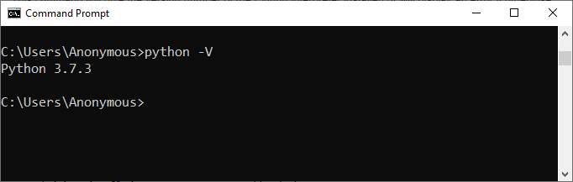

1. Run Python Script Interactively
In Python Interactive Mode, you can run your script line by line in a sequence. To enter an interactive mode, you will have to open Command Prompt on your Windows machine, type ‘python’ and press Enter.
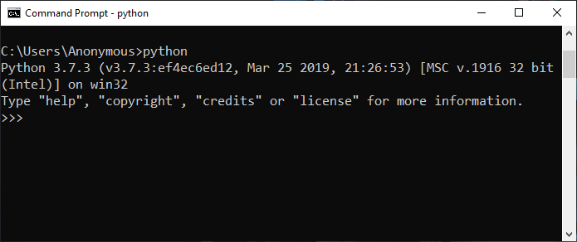

Example1: Using Print Function
Run the following line in the interactive mode:
print('Hello World !')
Output:
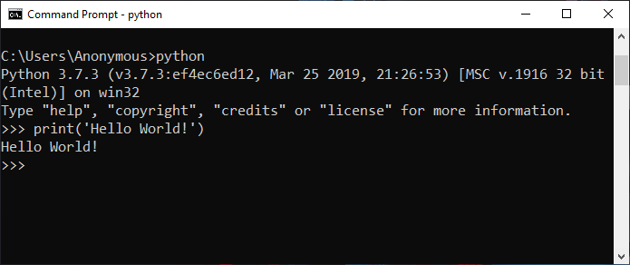

Example 2: Using Interactive Execution
Run the following lines one by one in the interactive mode.
name = "Aakash"
print("My name is " + name)
Output:
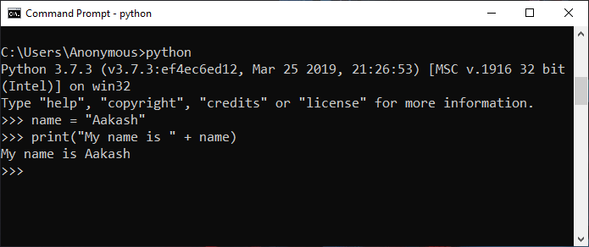

Example 3: Interactive Mode Comparison
Run the following lines one by one in the interactive mode.
a = 1
b = 3
if a > b:
print("a is Greater")
else:
print("b is Greater")
Output:
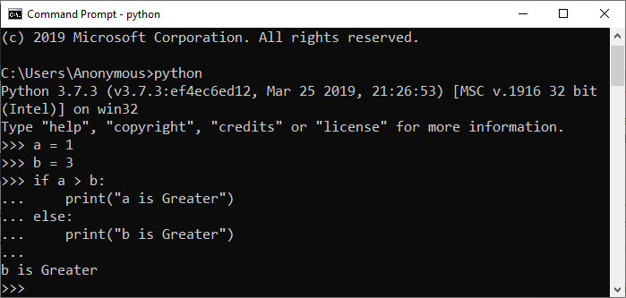
Note: To exit from this mode, press ‘Ctrl+Z’ and then press ‘Enter’ or type ‘exit()’ and then press Enter.

2. Run Python Script by the Command Line
Running Python scripts on Windows via the command line provides a direct and efficient way to execute code. It allows for easy navigation to the script’s directory and initiation, facilitating quick testing and automation.

Example 1: Using Script Filename
To run Python in the terminal, store it in a ‘.py’ file in the command line, we have to write the ‘python’ keyword before the file name in the command prompt. In this way we can run Python programs in cmd.
python hello.py
You can write your own file name in place of ‘hello.py’.
Output:
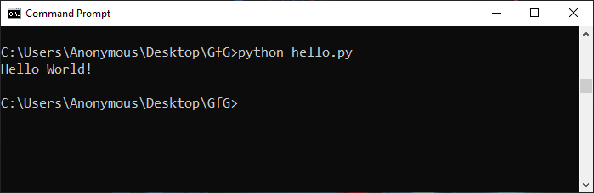

Example 2: Redirecting output
To run a Python script in Terminal from the command line, navigate to the script’s directory and use the python script_name.py command. Redirecting output involves using the > symbol followed by a file name to capture the script’s output in a file. For example, python script_name.py > output.txt redirects the standard output to a file named “output.txt.”
Output :
Output

3. Run a Script in Python using a Text Editor
To run Python script on a text editor like VS Code (Visual Studio Code) then you will have to do the following:
- Go to the extension section or press ‘Ctrl+Shift+X’ on Windows, then search and install the extension named ‘Python’ and ‘Code Runner’. Restart your vs code after that.
- Now, create a new file with the name ‘hello.py’ and write the below code in it:
print('Hello World!')
- Then, right-click anywhere in the text area and select the option that says ‘Run Code’ or press ‘Ctrl+Alt+N’ to run the code.
Output:
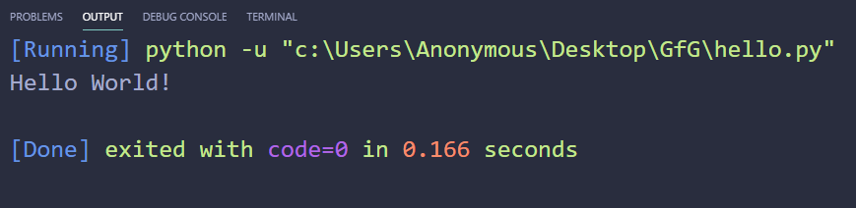

4. Run Python Scripts using an IDE
To run Python script on an IDE (Integrated Development Environment) like PyCharm, you will have to do the following:
- Create a new project.
- Give a name to that project as ‘GfG’ and click on Create.
- Select the root directory with the project name we specified in the last step. Right-click on it, go to New, anto, and click on the ‘Python file’ option. Then give the name of the file as ‘hello’ (you can specify any name as per your project requirement). This will create a ‘hello.py’ file in the project root directory.
Note: You don’t have to specify the extension as it will take it automatically.
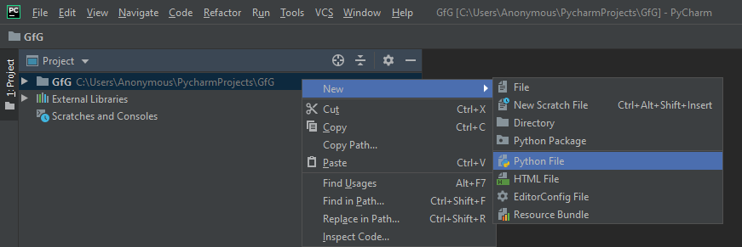
- Now write the below Python script to print the message:
print('Hello World !')
- To run this Python script, Right click and select the ‘Run File in Python Console’ option. This will open a console box at the bottom and show the output there. We can also run using the Green Play Button at the top right corner of the IDE.
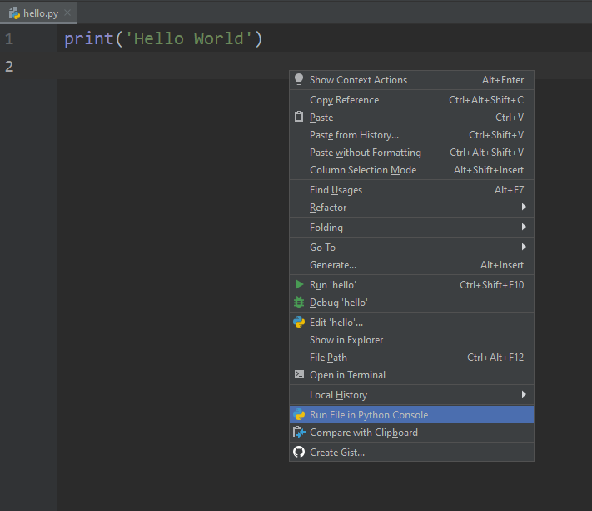
Output:
